Solve the Water Jug SIMATS ENGINEERING
ASSESSMENT TOOL 1

COURSE NAME: Artificial Intelligence COURSE CODE: CSA17

COURSE OUTCOME COVERED

CO1: Apply AI basics such as intelligent agents and uninformed search methods to solve problems effectively. (BL3)

Assessment Tool Weightage: 50%

QUESTIONS: 5 Duration : 1 Hour
Total Marks:5
Annexure A
Analytical Problem Solving

Code of Conduct:

I ____M.SHARMILA(192572139)________________ (Name / Reg No) certify that this submission is my original work and that I have adhered to the guidelines specified for this assessment.
I understand that any violation of academic integrity rules will result in disciplinary action.

Signature of the student:
Annexure A

Analytical Problem Solving

- Solve the Water Jug problem: you are given 2 jugs, a 4-gallon one and 3-gallon one. Neither has any measuring maker on it. There is a pump that can be used to fill the jugs with water. How can you get exactly 2 gallons of water into 4-gallon jug? Explicit assumptions: A jug can be filled from the pump, water can be poured out of a jug onto the ground, water can be poured from one jug to another and that there are no other measuring devices available.
2.Find out how Mars Rover, analyse and explore the samples on Mars by answering the following questions.
- What are the percept’s for this agent?
- Characterize the operating environment.
- What are the actions the agent can take?
- How can one evaluate the performance of the agent?
- What sort of agent architecture do you think is most suitable for this agent? Why?
- Explore the search space using search strategies and formulate the problem components for the 8-Queens problem using the following information: Place 8 queens on a chessboard such that none of the queen’s attack any of the others. A configuration of 8 queens on the board as shown in the figure below, but this does not represent a solution as the queen in the first column is on the same diagonal as the queen in the last column.
- A customer wants to travel from the one location to another location using OLA Cab booking mobile application. The customer can select the any of the cab type as mini, micro, sedan, shared, prime and so on based on his comfort to reach the destination. Identify what type of problem-solving agent can be used and write the pseudocode for the above problem.

- A logistics company operates a delivery network where packages must be transported between warehouses at minimum cost. Each route between warehouses has an associated travel cost (fuel + time). The company wants to determine the least-cost path from the starting warehouse S to the destination warehouse G using the Uniform Cost Search (UCS) algorithm.

The delivery network is represented as a weighted graph:
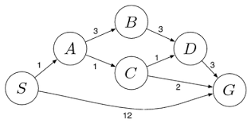

RUBRICS FOR CALCULATION:
Criteria | Weightage | Level 4 (Exemplary) | Level 3 (Proficient) | Level 2 (Developing) | Level 1 (Beginning)
Problem Understanding | 20% | Clearly interprets problem, identifies all parameters and requirements accurately | Understands problem with minor gaps | Partial understanding; misses key elements | Misinterprets or unable to understand problem
Method Selection | 20% | Selects most appropriate method/formula with strong justification | Selects correct method with minor errors | Inappropriate or partially correct method | Unable to select method
Solution Process | 25% | Logical, systematic steps with correct approach throughout | Mostly correct steps with minor mistakes | Disorganized steps; multiple errors | No clear process
Accuracy of Calculation | 20% | All calculations accurate; correct final answer | Minor calculation errors | Frequent errors; incorrect final answer | No valid calculations
Interpretation of Results | 15% | Clearly interprets results with units and engineering relevance | Basic interpretation with minor omissions | Limited or unclear interpretation | No interpretation
Problem Understanding | 20% | Clearly interprets problem, identifies all parameters and requirements accurately | Understands problem with minor gaps | Partial understanding; misses key elements | Misinterprets or unable to understand problem

1.Solve the Water Jug problem: you are given 2 jugs, a 4-gallon one and 3-gallon one. Neither has any measuring maker on it. There is a pump that can be used to fill the jugs with water. How can you get exactly 2 gallons of water into 4-gallon jug? Explicit assumptions: A jug can be filled from the pump, water can be poured out of a jug onto the ground, water can be poured from one jug to another and that there are no other measuring devices available.

1. Introduction
The Water Jug Problem is a classic Artificial Intelligence (AI) problem used to demonstrate state-space search and problem-solving techniques. The objective is to obtain a desired quantity of water by performing a sequence of valid operations on the available jugs.
Problem Statement
You are given:
- One 4-gallon jug
- One 3-gallon jug
- Neither jug has measurement markings.
- An unlimited water supply is available.
Allowed Operations
- Fill any jug completely.
- Empty any jug onto the ground.
- Pour water from one jug into another until:
  - the source jug becomes empty, or
  - the destination jug becomes full.
Goal
Measure exactly 2 gallons of water in the 4-gallon jug.

2. Problem Formulation
A problem in Artificial Intelligence consists of the following components:
Initial State
Both jugs are empty.
State = (0,0)
where
- First value = Water in 4-gallon jug
- Second value = Water in 3-gallon jug
Example:
(4,3)
means
- 4-gallon jug contains 4 gallons
- 3-gallon jug contains 3 gallons

State Space
Every possible combination of water in both jugs forms a state.
Example states:
(0,0)
(4,0)
(1,3)
(2,3)
(2,0)
(4,2)
...

Operators (Actions)
The possible actions are:
- Fill 4-gallon jug
- Fill 3-gallon jug
- Empty 4-gallon jug
- Empty 3-gallon jug
- Pour 4 → 3
- Pour 3 → 4

Goal State
(2,0)
The 4-gallon jug contains exactly 2 gallons.

3. State Space Diagram (Simplified)
(0,0)
/ \
Fill4 Fill3
| |
(4,0) (0,3)
| |
Pour4→3 Pour3→4
| |
(1,3) (3,0)
| |
Empty3 Fill3
| |
(1,0) (3,3)
| |
Pour1→4 Pour3→4
| |
(0,1) (4,2)
| |
Fill4 Empty4
| |
(4,1) (0,2)
|
Pour4→3
|
(2,3)
|
Empty3
|
(2,0) ← Goal

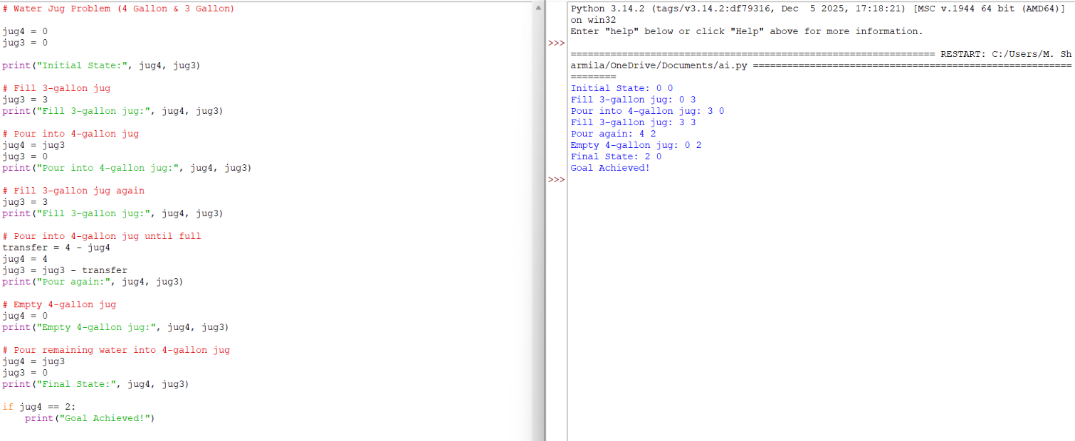
Code implementation
Implementation 1

4. Step-by-Step Solution
Step | Action | 4-Gallon Jug | 3-Gallon Jug
1 | Initial state | 0 | 0
2 | Fill 3-gallon jug | 0 | 3
3 | Pour 3 → 4 | 3 | 0
4 | Fill 3-gallon jug again | 3 | 3
5 | Pour 3 → 4 until 4-gallon jug is full | 4 | 2
6 | Empty 4-gallon jug | 0 | 2
7 | Pour remaining 2 gallons into 4-gallon jug | 2 | 0
Goal Achieved
The 4-gallon jug contains exactly 2 gallons.

5. Search Tree
(0,0)
/ \
(4,0) (0,3)
| |
(1,3) (3,0)
| |
(1,0) (3,3)
| |
(0,1) (4,2)
| |
(4,1) (0,2)
|
(2,3)
|
(2,0)
Goal State:
(2,0)

6. Algorithm
Algorithm: Water Jug Problem
Step 1: Start.
Step 2: Initialize both jugs as empty.
Step 3: Fill the 3-gallon jug.
Step 4: Pour water into the 4-gallon jug.
Step 5: Fill the 3-gallon jug again.
Step 6: Pour water into the 4-gallon jug until it becomes full.
Step 7: Empty the 4-gallon jug.
Step 8: Transfer the remaining 2 gallons from the 3-gallon jug to the 4-gallon jug.
Step 9: Stop.

7. Pseudocode
START
Jug4 = 0
Jug3 = 0
Fill(Jug3)
Pour(Jug3 → Jug4)
Fill(Jug3)
Pour(Jug3 → Jug4)
Empty(Jug4)

Pour(Jug3 → Jug4)
IF Jug4 == 2 THEN
PRINT "Goal Reached"
ENDIF
STOP
9. Applications
The Water Jug Problem is used in:
- Artificial Intelligence
- State Space Search
- Breadth-First Search (BFS)
- Depth-First Search (DFS)
- Robot Planning
- Automated Problem Solving
- Decision Making Systems

10. Conclusion
The Water Jug Problem is a fundamental AI search problem that illustrates how an intelligent agent explores a state space to reach a goal state using valid operations. By systematically applying fill, empty, and pour actions, the agent successfully measures exactly 2 gallons of water in the 4-gallon jug. This problem demonstrates the practical application of search algorithms such as Breadth-First Search (BFS) and Depth-First Search (DFS) in artificial intelligence.

Question 2: Mars Rover – Analyze and Explore Samples on Mars (10 Marks)
Introduction
A Mars Rover is an intelligent robotic vehicle designed by space agencies such as NASA to explore the surface of Mars. It operates autonomously or with limited human control to analyze rocks, soil, atmosphere, and search for signs of past or present life. Since communication between Earth and Mars has a significant time delay, the rover must make many decisions independently using Artificial Intelligence (AI).
Examples of Mars rovers include Sojourner, Spirit, Opportunity, Curiosity, and Perseverance.

i. What are the Percepts of this Agent? (2 Marks)
Definition
Percepts are the information or observations that an intelligent agent receives from its environment through sensors.
Percepts of a Mars Rover
The Mars Rover gathers information using various sensors, such as:
- Images from cameras (terrain, rocks, obstacles)
- Distance to nearby objects (using LiDAR or ultrasonic sensors)
- Soil composition data
- Rock composition and mineral analysis
- Atmospheric conditions (temperature, pressure, humidity)
- Weather information (wind speed and dust storms)
- GPS-like localization and position estimation
- Wheel status and battery level
- Radiation levels
- Surface slope and terrain characteristics
Table: Sensors and Percepts
Sensor | Percept Received
Camera | Images of rocks, terrain, obstacles
Spectrometer | Chemical composition of rocks and soil
Temperature Sensor | Surface temperature
Pressure Sensor | Atmospheric pressure
Proximity Sensor | Distance to obstacles
Navigation Sensor | Position and direction
Battery Sensor | Battery status
Weather Sensor | Wind speed and dust conditions

ii. Characterize the Operating Environment (2 Marks)
The Mars Rover operates in a challenging and uncertain environment.
Operating Environment Characteristics
Characteristic | Description
Observable | Partially Observable – The rover cannot observe the entire environment at once.
Agents | Single Agent – Only the Mars Rover performs the exploration task.
Determinism | Stochastic – Outcomes may be affected by dust storms, wheel slippage, or uneven terrain.
Episodes | Sequential – Current actions influence future states and decisions.
Dynamics | Dynamic – Environmental conditions such as weather and terrain can change.
State Space | Continuous – The rover moves through continuous space with varying positions and directions.
Knowledge | Partially Known – Some information is known from satellite images, but many regions are unexplored.
Summary
The Mars Rover operates in a partially observable, stochastic, sequential, dynamic, continuous, single-agent, and partially known environment.

iii. What Actions Can the Agent Take? (2 Marks)
The Mars Rover performs several actions to achieve its mission objectives.
Possible Actions
- Move forward
- Move backward
- Turn left
- Turn right
- Stop
- Avoid obstacles
- Capture images
- Analyze rocks
- Drill into rocks
- Collect soil samples
- Store collected samples
- Measure atmospheric conditions
- Transmit data to Earth
- Recharge using solar panels (for solar-powered rovers)
- Enter power-saving mode
- Plan a safe navigation route
Action Diagram
Mars Rover

│
┌─────────────┼─────────────┐
│ │ │
Move Collect Analyze
│ Samples Data
│ │ │
Avoid Store Send to Earth
Obstacle Samples

iv. How Can One Evaluate the Performance of the Agent? (2 Marks)
Performance Measure
A performance measure evaluates how effectively the Mars Rover achieves its goals.
Performance Criteria
- Successfully reaches the destination Collects maximum scientific sample
- Accurately analyzes rocks and soil
- Avoids obstacles safely
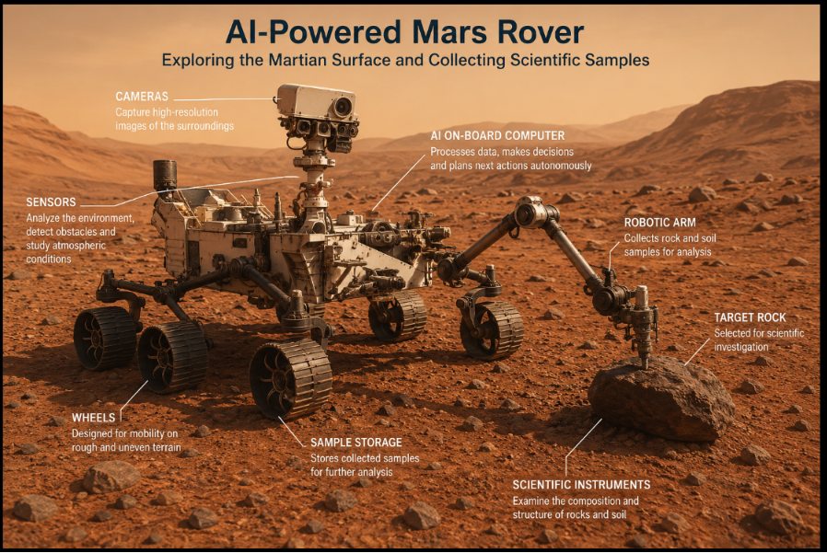
- Conserves battery power
- Completes assigned tasks within the mission time
- Sends accurate data back to Earth
- Minimizes equipment damage
- Operates reliably under harsh environmental conditions
Performance Evaluation Table
Sample Collection - | Maximum samples collected
Navigation - | Safe path with no collisions
Battery Usage - | Efficient power consumption
Communication - | Accurate data transmission
Scientific Analysis - | High-quality experimental results
Mission Completion - | All assigned tasks completed

Performance Measure | Desired Outcome
Sample Collection - | Maximum samples collected
Navigation - | Safe path with no collisions
Battery Usage - | Efficient power consumption
Communication - | Accurate data transmission
Scientific Analysis - | High-quality experimental results
Mission Completion - | All assigned tasks completed

v. Suitable Agent Architecture and Justification
Recommended Agent Architecture: Utility-Based Learning Agent
.
A Utility-Based Learning Agent is the most suitable architecture for a Mars Rover because it not only learns from its environment but also selects actions that maximize mission success while minimizing risks

Components of the Architecture
Environment
│
Sensors
│
Perception
│
Learning Element
│
Utility-Based Decision
│
Problem-Solving Module
│
Actuators
│
Environment
Why Utility-Based Learning Agent?
- Learns from previous experiences.
- Makes intelligent decisions under uncertainty.
- Chooses actions that maximize scientific value.
- Conserves battery and other resources.
- Adapts to new terrain and unexpected obstacles.
- Improves navigation over time.
- Handles changing environmental conditions effectively.
- Balances multiple goals, such as safety, energy efficiency, and scientific exploration.
Advantages
- High autonomy
- Adaptive behavior
- Efficient decision-making
- Better resource management
- Reliable performance in unknown environments

Simple Pseudocode
START
Initialize sensors and battery
WHILE mission is not complete DO
Sense the environment
Capture images
Detect obstacles
IF obstacle exists THEN
Find alternate safe path
ELSE
Move forward
ENDIF
IF interesting rock is detected THEN
Analyze rock
Collect sample
Store sample
ENDIF
Record environmental data
Send collected information to Earth
Monitor battery level
END WHILE
STOP
Applications of Mars Rover AI
- Space exploration
- Planetary research
- Geological analysis
- Search for signs of life
- Autonomous robotic navigation
- Scientific data collection
- Environmental monitoring

Conclusion
The Mars Rover is an advanced intelligent agent that explores the Martian surface using AI. It perceives its surroundings through sensors, performs autonomous navigation, collects and analyzes samples, and communicates scientific data to Earth. Since it operates in a partially observable, dynamic, and uncertain environment, a Utility-Based Learning Agent architecture is the most appropriate because it enables the rover to adapt, make optimal decisions, and maximize mission success while ensuring safety and efficient resource utilization.

Question 3: Explore the Search Space Using Search Strategies and Formulate the Problem Components for the 8-Queens Problem

1. Introduction
The 8-Queens Problem is a well-known problem in Artificial Intelligence (AI) that demonstrates state-space search and constraint satisfaction. The objective is to place eight queens on an 8 × 8 chessboard such that no two queens attack each other.
A queen in chess can move:
- Horizontally
- Vertically
- Diagonally
Therefore, no two queens should be in the same row, same column, or same diagonal.

2. Problem Statement
Place 8 queens on an 8 × 8 chessboard so that:
- No two queens are in the same row.
- No two queens are in the same column.
- No two queens are on the same diagonal.
The given configuration is not a solution because the queen in the first column lies on the same diagonal as the queen in the last column.

Python code implementation
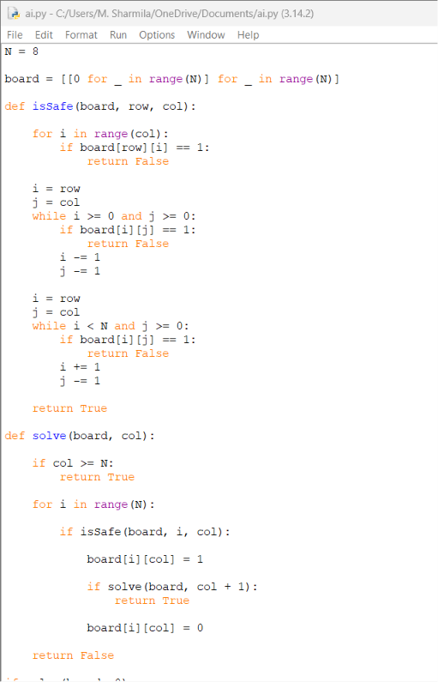
OUTCOME
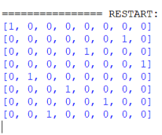
3. Problem Formulation
a) Initial State
The chessboard is empty.
No queens are placed.

b) State
A state represents the arrangement of queens on the chessboard.
Example:
State = (1,5,8,6,3,7,2,4)
Each number represents the row position of the queen in its respective column.
For example:
Column | Row
1 | 1
2 | 5
3 | 8
4 | 6
5 | 3
6 | 7
7 | 2
8 | 4

c) Initial State Representation
□□□□□□□□
□□□□□□□□
□□□□□□□□
□□□□□□□□
□□□□□□□□
□□□□□□□□
□□□□□□□□
□□□□□□□□
(No queens placed)

d) Operators (Actions)
The agent can perform the following action:
- Place a queen in a safe position.
- Move a queen to another row.
- Backtrack if a conflict occurs.

e) Goal State
A configuration where:
- All 8 queens are placed.
- No two queens attack each other.
Example of a valid solution:
Q . . . . . . .
. . . . Q . . .
. . . . . . . Q
. . . . . Q . .
. . Q . . . . .
. . . . . . Q .
. Q . . . . . .
. . . Q . . . .

4. State Space
The state space is the collection of all possible arrangements of queens on the board.
If every square is considered,
64 × 63 × 62 × ...
possible arrangements exist.
However, since only one queen is placed in each column, the state space reduces significantly.
The search algorithm explores only the valid states.

5. Constraints
The following constraints must always be satisfied.
Constraint 1
No two queens should be in the same row.
Example (Invalid)
Q Q . . . . . .

Constraint 2
No two queens should be in the same column.
Example (Invalid)
Q
Q

Constraint 3
No two queens should be on the same diagonal.
Example (Invalid)
Q . . .
. Q . .
. . Q .
. . . Q

6. Search Space Tree
Start
|
Place Queen in Column 1
|
---------------------------------
| | | | |
Row1 Row2 Row3 Row4 ...
|
Place Queen in Column 2
|
------------------------
| | | |
Safe Unsafe Safe Unsafe
|
Continue Search
|
Goal State
The search continues until all eight queens are placed successfully.

7. Search Strategies Used
The 8-Queens problem can be solved using different AI search strategies.
a) Depth-First Search (DFS)
- Places queens one column at a time.
- Continues until a conflict occurs.
- Uses backtracking.
- Requires less memory.
b) Breadth-First Search (BFS)
- Explores all possible states level by level.
- Finds a solution but requires large memory.
c) Backtracking Search (Most Common)
- Places queens one by one.
- If a conflict occurs, returns to the previous queen.
- Tries another position.
This is the most efficient and widely used method.
d) Heuristic Search
Uses heuristic functions to reduce unnecessary exploration and reach the solution faster.

8. Backtracking Algorithm
Algorithm
Step 1: Start.
Step 2: Place the first queen in Column 1.
Step 3: Move to the next column.
Step 4: Check whether the position is safe.
Step 5: If safe, place the queen.
Step 6: Otherwise, try the next row.
Step 7: If no row is safe,
backtrack to the previous column.
Step 8: Repeat until all eight queens are placed.
Step 9: Display the solution.
Step 10: Stop.
9. Pseudocode
procedure Solve(col)
if col > 8
print Solution
return TRUE
for each row from 1 to 8
if Safe(row, col)
Place Queen(row, col)
if Solve(col + 1)
return TRUE
Remove Queen(row, col)
return FALSE
12. Applications of the 8-Queens Problem
- Artificial Intelligence (AI)
- Constraint Satisfaction Problems (CSP)
- Backtracking Algorithms
- Robotics Path Planning
- Task Scheduling
- Resource Allocation
- Optimization Problems
- Game Development

13. Advantages
- Demonstrates state-space search techniques.
- Introduces constraint satisfaction concepts.
- Efficiently solved using backtracking.
- Helps understand recursive algorithms.
- Widely used in AI education and research.

14. Conclusion
The 8-Queens Problem is a classic Constraint Satisfaction Problem (CSP) in Artificial Intelligence. It involves placing eight queens on a chessboard such that no two queens threaten each other. By formulating the problem with an initial state, state space, operators, constraints, and goal state, AI search strategies such as Depth-First Search (DFS) and Backtracking can efficiently find a valid solution. Due to its simplicity and effectiveness, the 8-Queens Problem remains an important example for studying search algorithms, recursion, and optimization techniques in AI.

Question 4: A Customer Wants to Travel Using the OLA Cab Booking Mobile Application – Identify the Problem-Solving Agent and Write the Pseudocode

1. Introduction
An OLA Cab Booking System is an example of an Artificial Intelligence (AI)-based Problem-Solving Agent. It helps customers book a suitable cab by analyzing user requirements such as pickup location, destination, cab type, fare, availability, and estimated arrival time.
The intelligent agent perceives the environment, processes the information, selects the most appropriate cab, and performs the booking to achieve the user's goal.

2. Problem Statement
A customer wants to travel from one location to another using the OLA Cab Booking mobile application. The customer can choose from different cab types such as:
- Mini
- Micro
- Sedan
- Prime
- Share
The AI agent should identify the best available cab based on the customer's preferences and complete the booking.

3. Problem Formulation
Initial State
- Customer opens the OLA application.
- No cab is booked.

State Space
The state space includes all possible booking options available to the customer.
Example:
- Different cab types
- Different drivers
- Various routes
- Different fare prices
- Estimated arrival times

Actions (Operators)
The intelligent agent can perform the following actions:
- Detect current location.
- Accept destination.
- Display available cab types.
- Calculate fare.
- Estimate arrival time.
- Search for nearby drivers.
- Allocate the nearest driver.
- Confirm booking.
- Track the ride.
- Complete payment.
Goal State
The customer successfully reaches the destination after completing the ride.

4. PEAS Representation
PEAS (Performance Measure, Environment, Actuators, Sensors) is used to describe an intelligent agent.
Component | Description
Performance Measure | Fast booking, minimum waiting time, shortest route, low fare, customer satisfaction
Environment | Roads, GPS, traffic, drivers, passengers, weather conditions
Actuators | Mobile screen, booking confirmation, navigation system, notifications
Sensors | GPS, internet, customer location, destination input, traffic data

5. Type of Intelligent Agent
The Goal-Based Agent is the most suitable intelligent agent for the OLA Cab Booking System.
Reason
A Goal-Based Agent selects actions that help achieve a specific goal.
The goal is:
Transport the customer safely from the pickup location to the destination with minimum cost and waiting time.
The agent continuously evaluates different options before making the booking.

6. Working of the Goal-Based Agent
Step 1
Customer enters:
- Pickup location
- Destination
↓
Step 2
Agent collects information:
- GPS location
- Nearby drivers
- Traffic condition
- Available cab types
↓
Step 3
Agent calculates:
- Estimated fare
- Distance
- Estimated arrival time
↓
Step 4
Agent displays:
- Mini
- Micro
- Sedan
- Prime
- Share
↓
Step 5
Customer selects the preferred cab.
↓
Step 6
Agent assigns the nearest available driver.
↓
Step 7
Driver reaches the pickup location.
↓
Step 8
Trip starts.
↓
Step 9
Customer reaches the destination.
↓
Step 10
Payment is completed.

7. Flow Diagram
Customer Opens OLA App
│
▼
Enter Pickup & Destination
│
▼
AI Agent Receives Request
│
▼
Search Nearby Drivers
│
▼
Calculate Distance & Fare
│
▼
Display Available Cab Types
│
▼
Customer Selects Cab
│
▼
Assign Nearest Driver
│
▼
Ride Starts
│
▼
Reach Destination
│
▼
Payment Completed

8. Algorithm
Algorithm: OLA Cab Booking
- Start.
- Open the OLA application.
- Enter the pickup location.
- Enter the destination.
- Detect the customer's current location using GPS.
- Search for nearby available drivers.
- Calculate the distance, estimated fare, and arrival time.
- Display available cab types (Mini, Micro, Sedan, Prime, Share).
- Customer selects a preferred cab.
- Assign the nearest available driver.
- Confirm the booking.
- Track the ride using GPS.
- Complete the ride and process payment.
- Stop.

9. Pseudocode
START
Input Pickup_Location
Input Destination

Detect Current Location using GPS
Search Available Driver
Calculate Distance
Calculate Fare
Display Cab Types
Input Selected_Cab
IF Driver Available THEN
Assign Driver
Confirm Booking
Start Ride
Track Ride
Complete Payment
Print "Trip Completed Successfully"
ELSE
Print "No Cab Available"

ENDIF
STOP

CODE IMPLEMENTATION
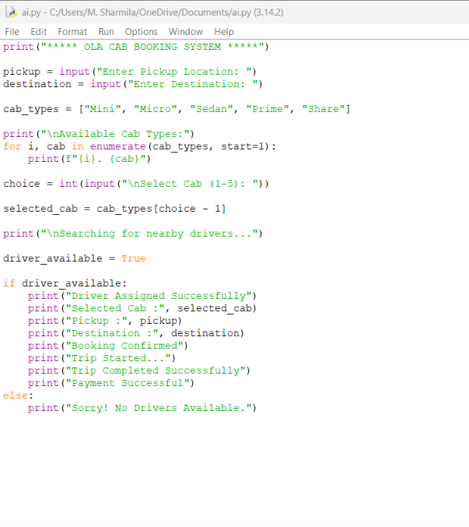
OUTPUT
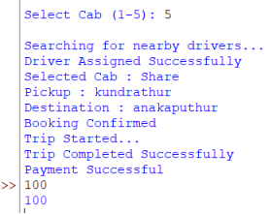

12. Advantages
- Easy and convenient booking.
- Saves travel time.
- Displays multiple cab options.
- Provides estimated fare before booking.
- Tracks the ride in real time using GPS.
- Ensures secure online payment.
- Improves customer satisfaction through efficient service.

13. Applications
- OLA
- Uber
- Rapido
- Taxi booking services
- Logistics and transportation systems
- Ride-sharing platforms

14. Conclusion
The OLA Cab Booking System is a practical application of an AI Goal-Based Agent. The agent collects information such as the customer's location, destination, nearby drivers, traffic conditions, and cab availability, then determines the best cab option to achieve the user's goal. By using search strategies and decision-making, the system provides an efficient, cost-effective, and user-friendly transportation service.

Question 5: A Logistics Company Operates a Delivery Network Where Packages Must Be Transported Between Warehouses at Minimum Cost. Each Route Between Warehouses Has an Associated Cost. Formulate the Problem Using AI Search Techniques and Write the Algorithm/Pseudocode.

1. Introduction
A Logistics Network is a transportation system that moves packages from one warehouse to another through interconnected routes. In Artificial Intelligence (AI), this problem is modeled as a Shortest Path Search Problem, where the objective is to determine the least-cost route between a source warehouse and a destination warehouse.
AI search algorithms such as Uniform Cost Search (UCS), Dijkstra's Algorithm, and A* Search are commonly used to solve this problem efficiently.

2. Problem Statement
A logistics company operates multiple warehouses connected by transportation routes. Each route has a specific transportation cost. The objective is to transport packages from a source warehouse to a destination warehouse while minimizing the total transportation cost.

3. Problem Formulation
Initial State
- Package is at the source warehouse.
Example:
Warehouse A

State Space
The state space consists of all warehouses and the possible routes connecting them.
Example:
A → B → C → D → E
Each warehouse represents a state.

Actions (Operators)
The AI agent can perform the following actions:
- Move package from one warehouse to another.
- Calculate transportation cost.
- Compare different routes.
- Select the least-cost path.
- Deliver the package.

Goal State
The package reaches the destination warehouse with the minimum transportation cost.

4. Search Space Representation
Consider the following logistics network.
4
A -------- B
| | \
2 | |5 \10
| | \
C -------- D ---- E
3 2
Where:
- A = Source Warehouse
- E = Destination Warehouse
Edge costs:
- A → B = 4
- A → C = 2
- C → D = 3
- B → D = 5
- B → E = 10
- D → E = 2

5. State Space Tree
A
/ \
B C
/ \ \
D E D
\ /
\ /
E (Goal)
The search algorithm explores all possible routes and selects the one with the minimum total cost.

6. Search Strategy Used
Uniform Cost Search (UCS)
Uniform Cost Search expands the node with the lowest cumulative path cost.
Characteristics:
- Finds the optimal solution.
- Guarantees minimum transportation cost.
- Suitable when route costs are different.

Alternative Algorithms
- Dijkstra's Algorithm
- A* Search Algorithm
- Breadth-First Search (when all edge costs are equal)
Among these, Uniform Cost Search (UCS) is the most appropriate because it always chooses the least-cost path.

7. Working of the AI Agent
- Receive source and destination warehouses.
- Generate all possible routes.
- Calculate the total transportation cost for each route.
- Compare all route costs.
- Select the route with the minimum cost.
- Deliver the package.
- Display the optimal path and total cost.

8. Flow Diagram
Start
│
▼
Input Source Warehouse
│
▼
Input Destination Warehouse
│
▼
Generate All Possible Routes
│
▼
Calculate Route Cost
│
▼
Compare Costs
│
▼
Choose Minimum Cost Route
│
▼
Deliver Package
│
▼
Display Total Cost
│
▼
Stop

9. Algorithm
Algorithm: Minimum Cost Logistics Routing
- Start.
- Input source warehouse.
- Input destination warehouse.
- Read all available routes and transportation costs.
- Initialize the source node with cost 0.
- Explore neighboring warehouses.
- Calculate the cumulative cost for each route.
- Select the warehouse with the minimum cumulative cost.
- Repeat until the destination warehouse is reached.
- Display the shortest path and minimum transportation cost.
- Stop.

10. Pseudocode
START
Input Source
Input Destination
Initialize Cost(Source) = 0
Place Source in Priority Queue
WHILE Queue is not Empty
Remove Warehouse with Minimum Cost
IF Destination Reached THEN
Display Shortest Path
Display Minimum Cost
STOP
ENDIF
FOR each Neighbor Warehouse
Calculate New Cost
IF New Cost is Smaller THEN
Update Cost
Insert Neighbor into Queue
ENDIF
ENDFOR
ENDWHILE
STOP

Python code implementation
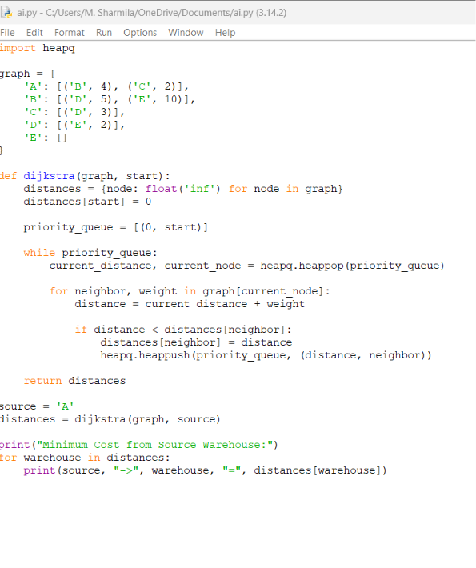

OUTPUT:
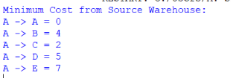
13. Advantages
- Finds the minimum transportation cost.
- Reduces delivery time.
- Optimizes route selection.
- Improves fuel efficiency.
- Suitable for large logistics networks.
- Ensures efficient resource utilization.

14. Applications
- Courier services
- E-commerce delivery systems
- Supply chain management
- Warehouse management
- Food delivery services
- Postal services
- Transportation and distribution networks

15. Conclusion
The logistics routing problem is a cost optimization problem in Artificial Intelligence. By representing warehouses as nodes and transportation routes as weighted edges, AI search algorithms such as Uniform Cost Search (UCS) and Dijkstra's Algorithm can identify the least-cost path between the source and destination. This approach minimizes transportation costs, improves delivery efficiency, and supports effective decision-making in logistics and supply chain management.

